COAL Lab 09 Assignment:

# Name: Owais Ali Khan

# Section: 3-F

# Roll no: 21K-3298

Question # 01:

TITLE Question 1

INCLUDE Irvine32.inc

INCLUDE Macros.inc

.data

.code

main PROC

mov eax, 0

mWrite "Enter value to be multiplied by 21: "

call ReadInt

mov ebx, eax

mov ecx, eax

shl eax, 4

shl ebx, 2

shl ecx, 0

add eax, ebx

add eax, ecx

mWrite "Answer: "

call WriteInt

call Crlf

exit

main ENDP

END main

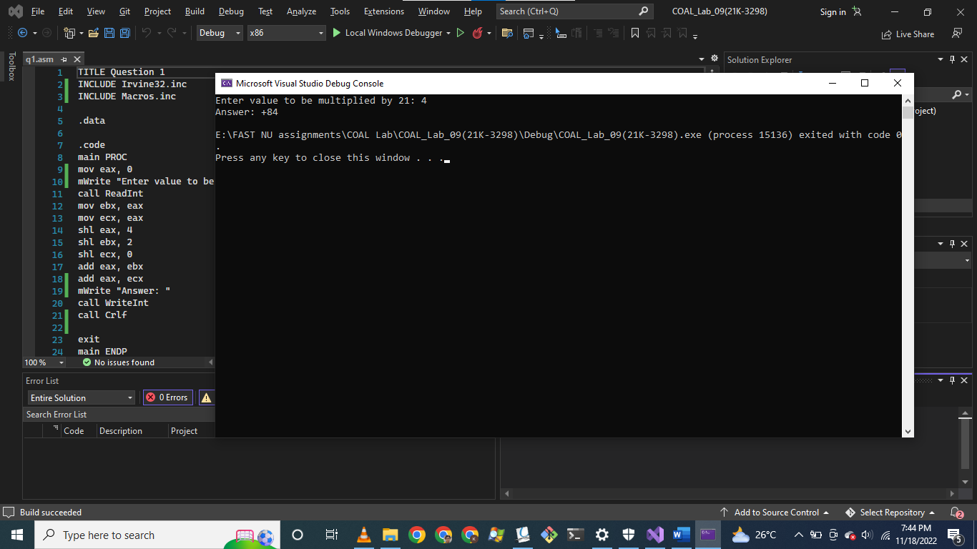

Question # 02:

TITLE Question 2

INCLUDE Irvine32.inc

.data

.code

main PROC

mov eax, 0

mov ax, -128

call WriteInt

call Crlf

sal eax, 16

sar eax, 16

call WriteInt

exit

main ENDP

END main

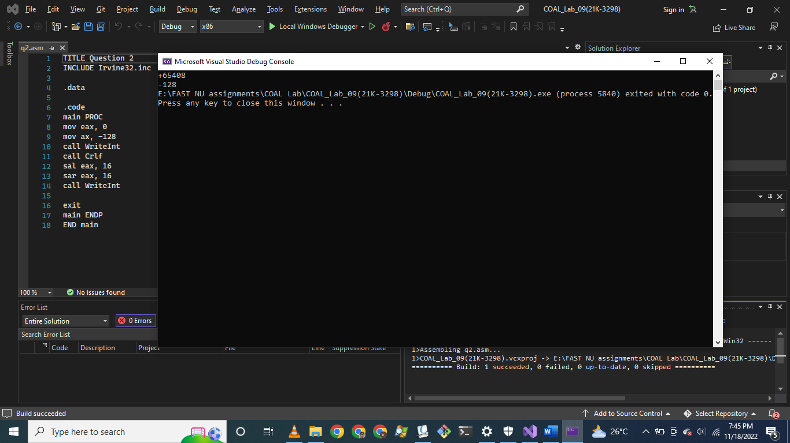

Question # 03:

TITLE Question 3

INCLUDE Irvine32.inc

.data

timeStamp WORD 1110001110000111b ; Minutes = 011100 = +28

bMinutes BYTE ?

.code

main PROC

mov eax, 0

mov ax, timeStamp

shr eax, 5

AND al, 00111111b

mov bMinutes, al

movzx eax, bMinutes

call WriteInt

call Crlf

call WriteBin

exit

main ENDP

END main

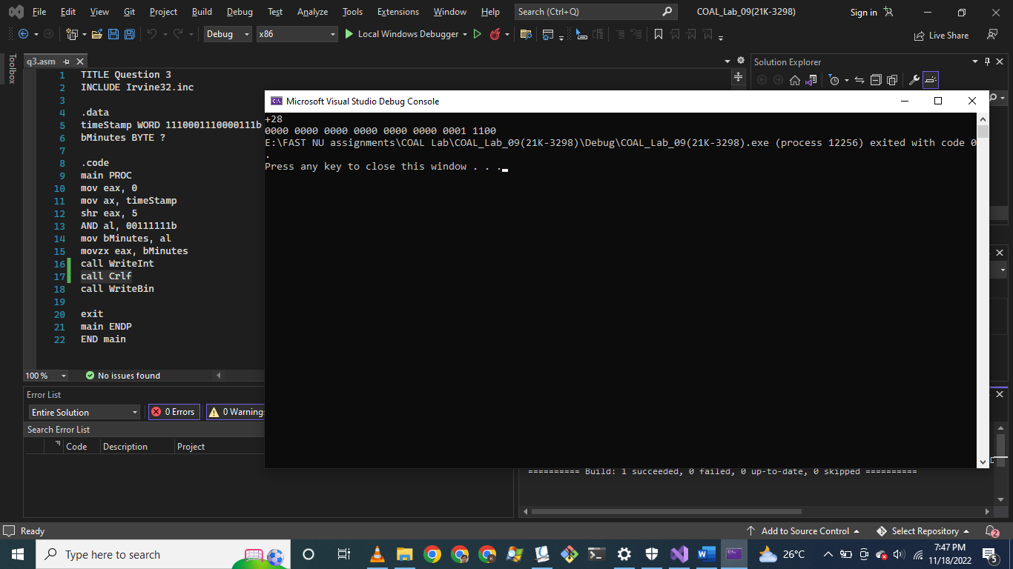

Question # 04:

TITLE Question 4

INCLUDE Irvine32.inc

INCLUDE Macros.inc

.data

.code

main PROC

mov eax, 0000000011111111b

mov ebx, 0000000000000000b

; Without SHRD

mWrite "Without SHRD Instruction"

call Crlf

ror ax, 1

rcr bx, 1

rol ax, 1

mWrite "eax = "

call WriteBin

call Crlf

mWrite "ebx = "

xchg eax, ebx

call WriteBin

call Crlf

call Crlf

xchg eax, ebx

; With SHRD

mWrite "With SHRD Instruction"

call Crlf

mov eax, 0000000011111111b

mov ecx, 0000000000000000b

shrd cx, ax, 1

mWrite "eax = "

call WriteBin

call Crlf

mWrite "ecx = "

xchg eax, ecx

call WriteBin

call Crlf

xchg eax, ebx

exit

main ENDP

END main

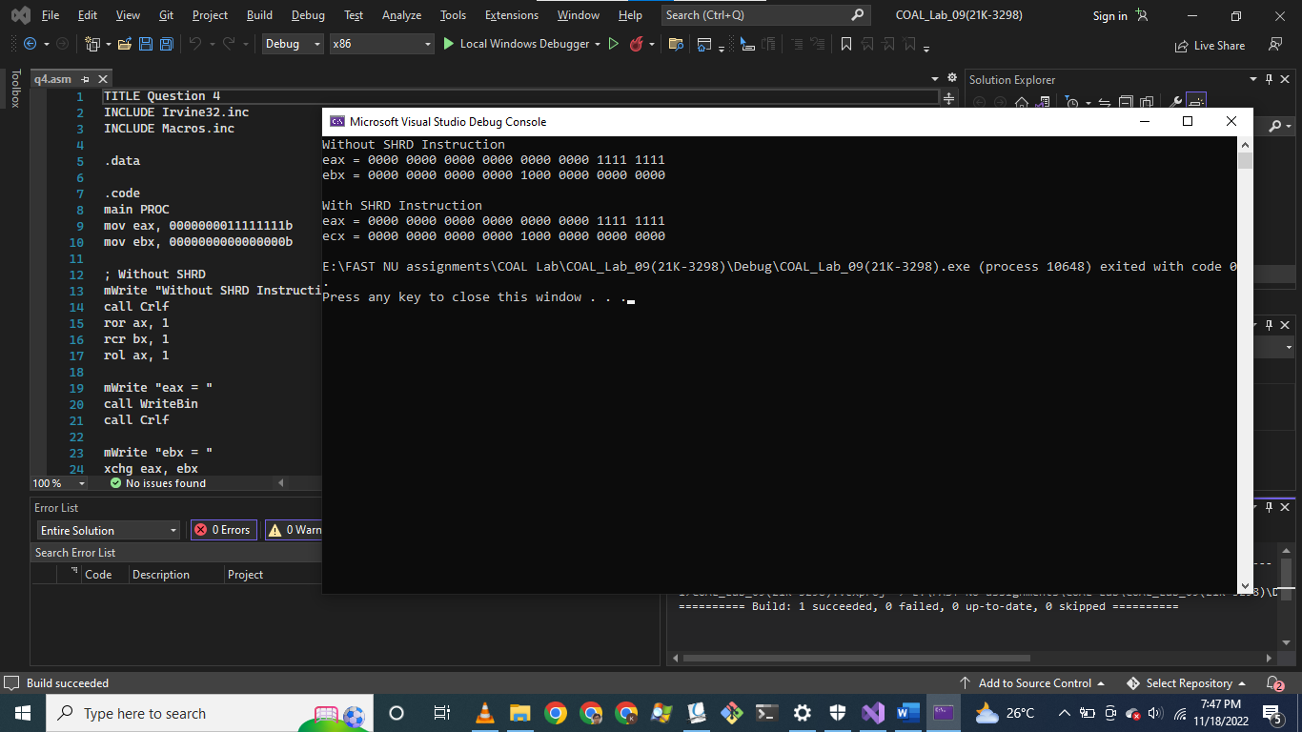

Question # 05:

TITLE Question 5

INCLUDE Irvine32.inc

INCLUDE Macros.inc

.data

val1 SDWORD 100

val2 SDWORD 10

val3 SDWORD 5

.code

main PROC

mov eax, val2

cdq

idiv val3

mov ebx, eax

call WriteInt

call Crlf

mov eax, val1

cdq

idiv val2

call WriteInt

call Crlf

call Crlf

imul ebx

xchg eax, edx

mWrite "EDX: "

call WriteInt

xchg eax, edx

mWrite " EAX: "

call WriteInt

call Crlf

exit

main ENDP

END main

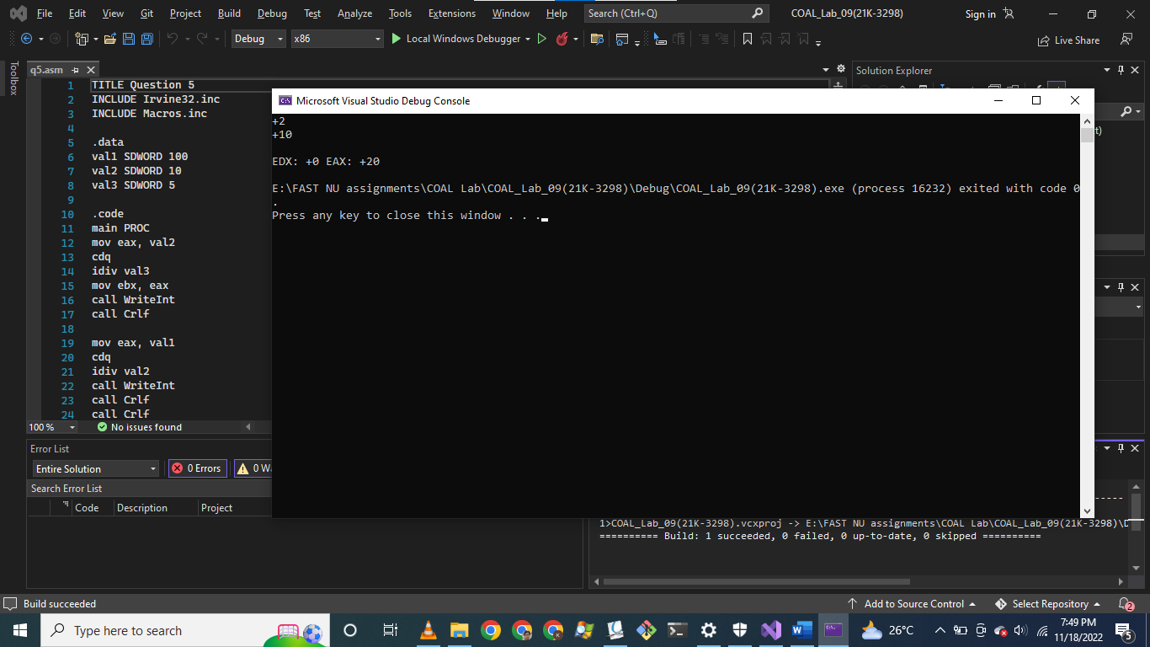

Question # 06:

TITLE Question 6

INCLUDE Irvine32.inc

INCLUDE Macros.inc

.data

first QWORD 0000FFFFFFFFFFFFh

second QWORD 0000EEEEEEEEEEEEh

.code

main PROC

push DWORD PTR second

push DWORD PTR second + 4

push DWORD PTR first

push DWORD PTR first + 4

call Extended_Add

exit

main ENDP

Extended_Add PROC ; Returns value in esi:eax:ebx with final carry in esi

mov eax, [esp + 4] ; 0000FFFF

mov ebx, [esp + 8] ; FFFFFFFF

mov ecx, [esp + 12] ; 0000EEEE

mov edx, [esp + 16] ; EEEEEEEE

mov esi, 0

call DumpRegs

add ebx, edx

adc eax, ecx

adc esi, 0

;adc eax, ebx

call Crlf

mWrite "Sum of 64-bit integers: "

xchg eax, esi

call WriteHex

xchg eax, esi

call WriteHex

xchg eax, ebx

call WriteHex

call Crlf

ret

Extended_Add ENDP

END main

